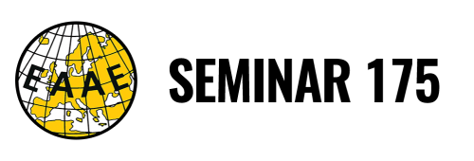

THE WIND OF CHANGE OF SUSTAINABILITY STANDARDS
Sailing economic, governance, and policy perspectives

Gargnano, 13 – 15 May 2020

Title of the organized session

Theme of the Proposed Organised Session

Abstract of the Proposed Organised Session
(Extended abstract of around 800 words describing the rationale, originality, contribution to the advancement of knowledge and relevance to Congress participants of the session)
Keywords
Organiser
(name, affiliation, contact details)
Chair person(s)
(name(s), affiliation(s), contact details)
Author(s) and Abstract of Contribution 1
(name(s), affiliation(s), contact details, abstract (max 200 words))
Follow the above example for the other contributions
Discussant(s)
Provide name(s), affiliation(s) and contact details

