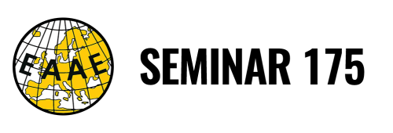

THE WIND OF CHANGE OF SUSTAINABILITY STANDARDS
Sailing economic, governance, and policy perspectives

Gargnano, 13 – 15 May 2020

Title of the paper

Keywords: keyword 1, keyword 2, …

Title of the paper

Please follow the following structure for your extended abstract. Allow a maximum of 3 pages.

Background and objectives
Insert text in Times New Roman 12. Insert tables or figures within the text.

Data and methods
Insert text in Times New Roman 12. Insert tables or figures within the text.

Results
Insert text in Times New Roman 12. Insert tables or figures within the text.

Discussion and conclusions
Insert text in Times New Roman 12

References
Please insert references using APA style

