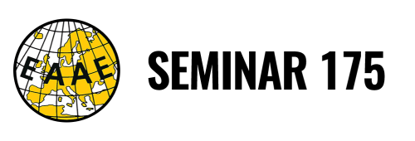

THE WIND OF CHANGE OF SUSTAINABILITY STANDARDS
Sailing economic, governance, and policy perspectives

Gargnano, 13 – 15 May 2020

Title of the poster

Abstract
Insert text in Times New Roman 12. Abstracts should not exceed 200 words.

Keywords: keyword 1, keyword 2, …

